**Exercise 9: Creating a Spring Boot Application**

**Scenario:**

**You need to create a Spring Boot application for the library management system to simplify configuration and deployment.**

**Steps:**

1. **We have to Create a Spring Boot Project:**
   * **Here , we will use Spring Initializr to create a new Spring Boot project named LibraryManagement.**

**Ans.**

Step1:- 1st , we will Open a browser >type <https://start.spring.io/> >open it.

Step 2:- And then Select Project as Maven > Language as Java>Spring boot as 3.3.2

Step 3:- Group as com.library > Artifact as LibraryManagement > Name as LibraryManagement > Package name as com.library > Click on Generate .

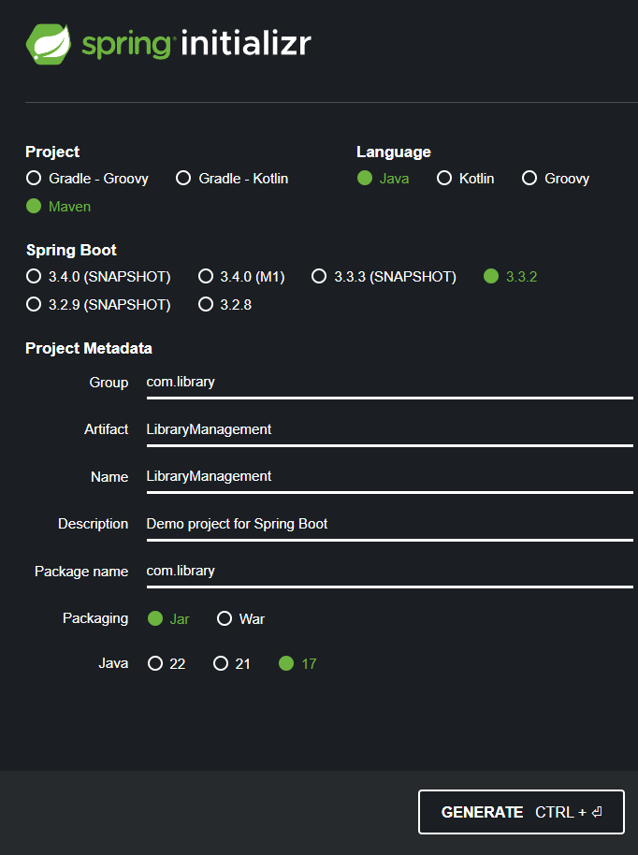

1. **Add Dependencies:**
   * **Include dependencies for Spring Web, Spring Data JPA, and H2 Database.**

**Ans.**

Step 1:- Click on the dependencies and search the dependencies , i.e.,Spring Web, Spring Data JPA, and H2 Database > Click on ok.

Step 2:- Click on generate

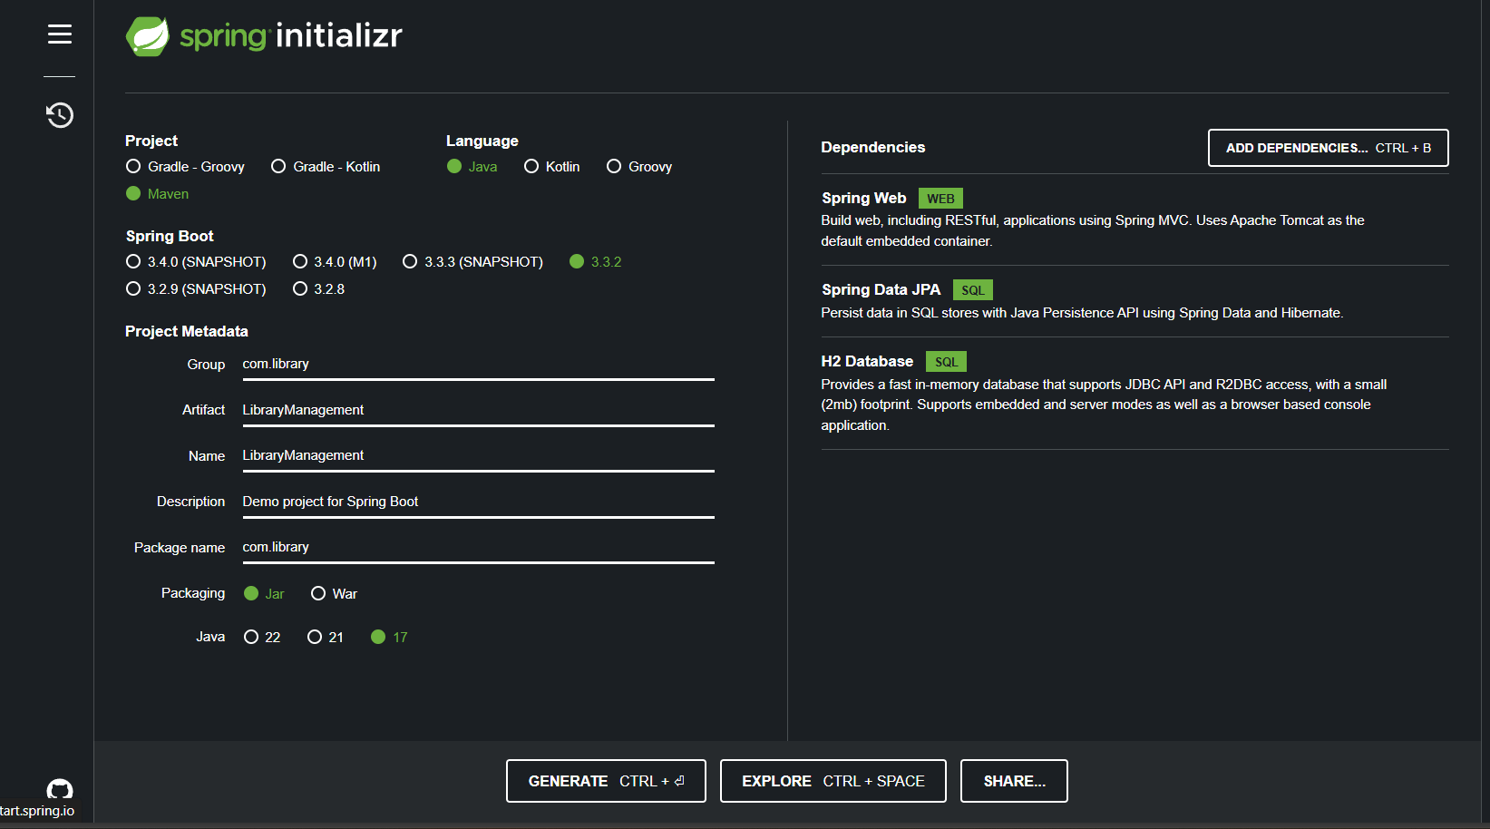

1. **Create Application Properties:**
   * **Configure database connection properties in application.properties.**

**Ans.**

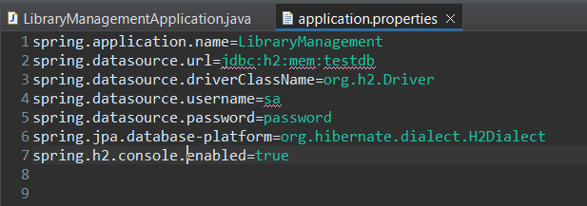

1. **Define Entities and Repositories:**
   * **Create Book entity and BookRepository interface.**

**Ans.**

Step 1: -Right-click on src/main/java and select New > Package.

Step 2: - Enter com.library.repository as the package name and click Finish.

Step 3: - Right-click on the newly created package and select New > Scrapbook Page.

Step 4: - Enter BookRepository.java as the Scrapbook Page name and click Finish.

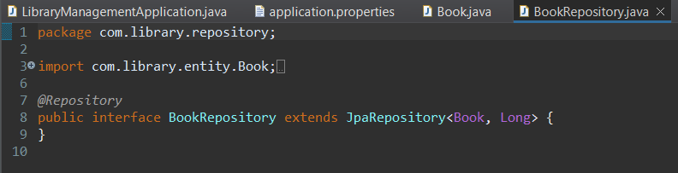

1. **Create a REST Controller:**
   * **Create a BookController class to handle CRUD operations.**

**Ans.**

Step 1: -Right-click on src/main/java and select New > Package.

Step 2: - Enter com.library.controller as the package name and click Finish.

Step 3: - Right-click on the newly created package and select New > Scrapbook Page.

Step 4: - Enter BookController.java as the Scrapbook Page name and click Finish.

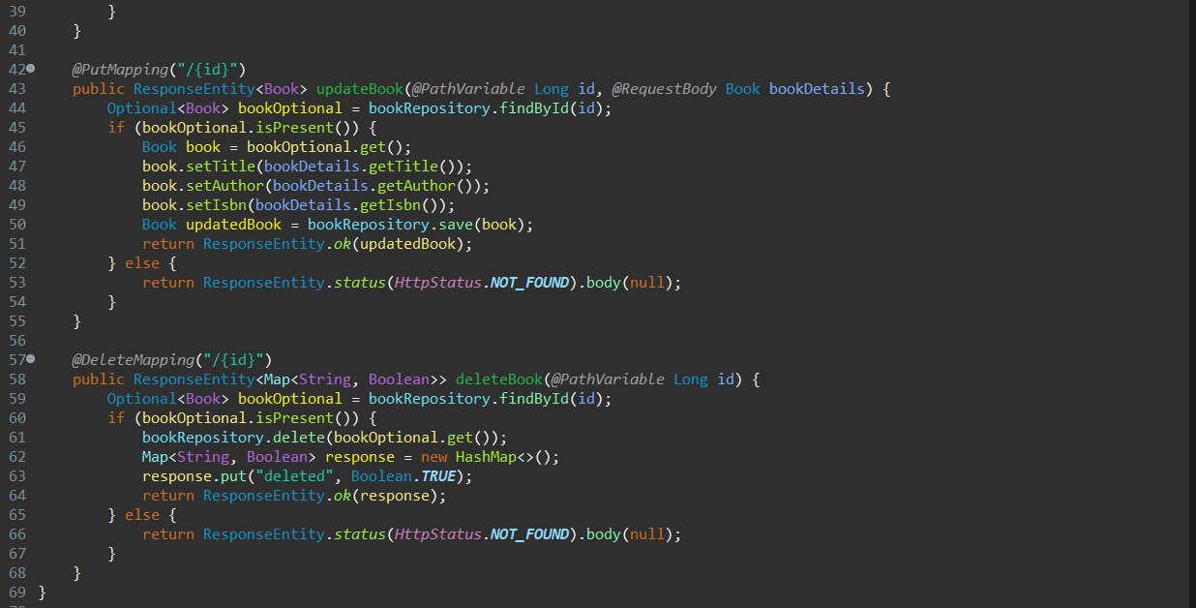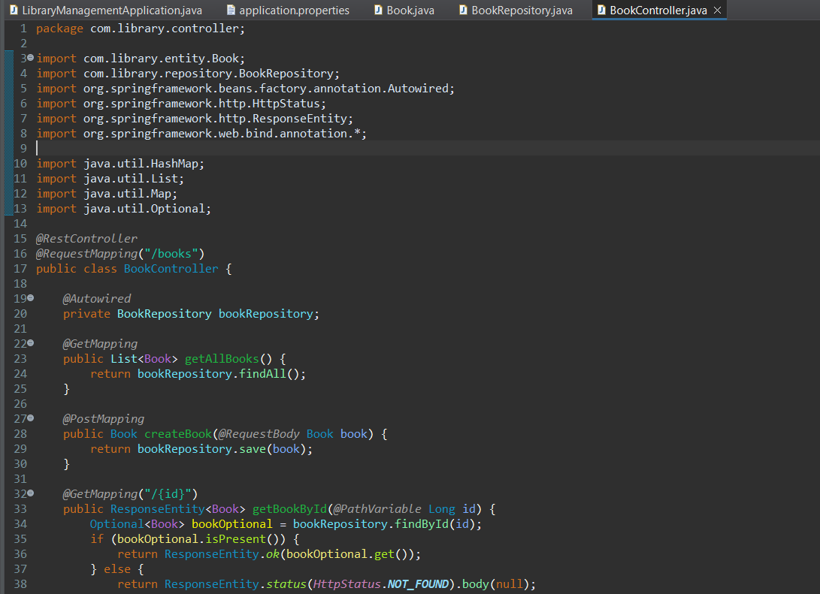

1. **Run the Application:**
   * 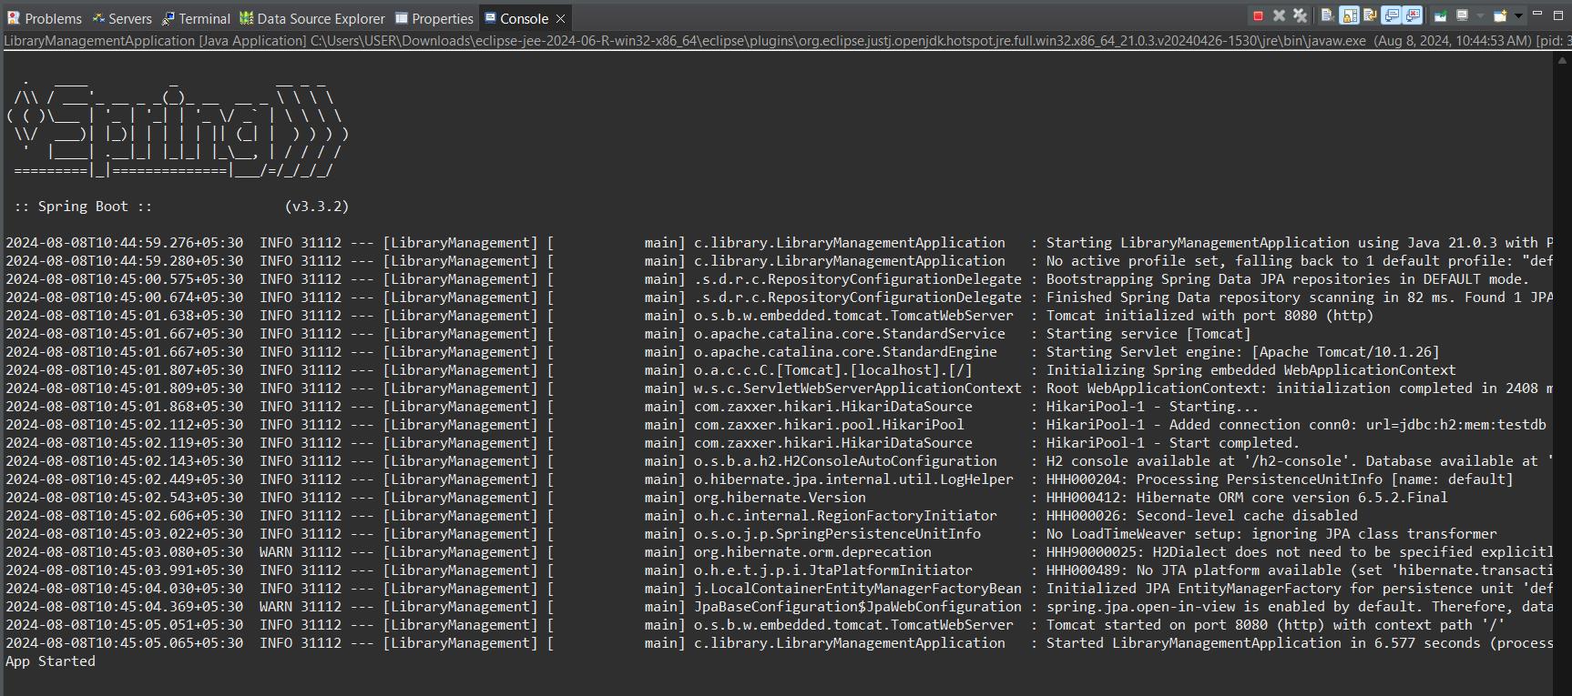**Run the Spring Boot application and test the REST endpoints.**

After Searching in the website by typing in the address bar . we search by <https://localhost.8080/h2-console>

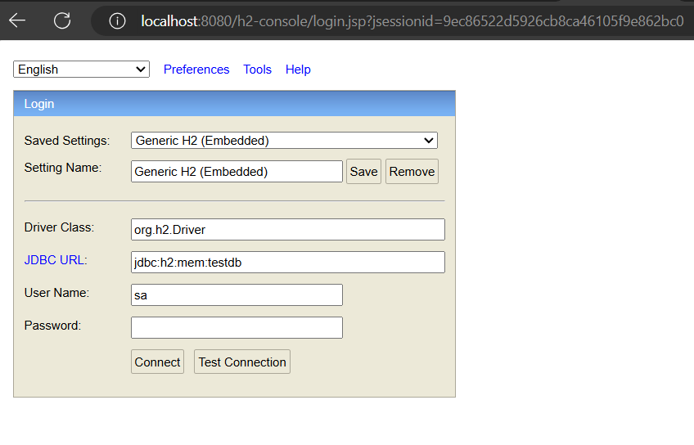Then we get it .

**Output: -**

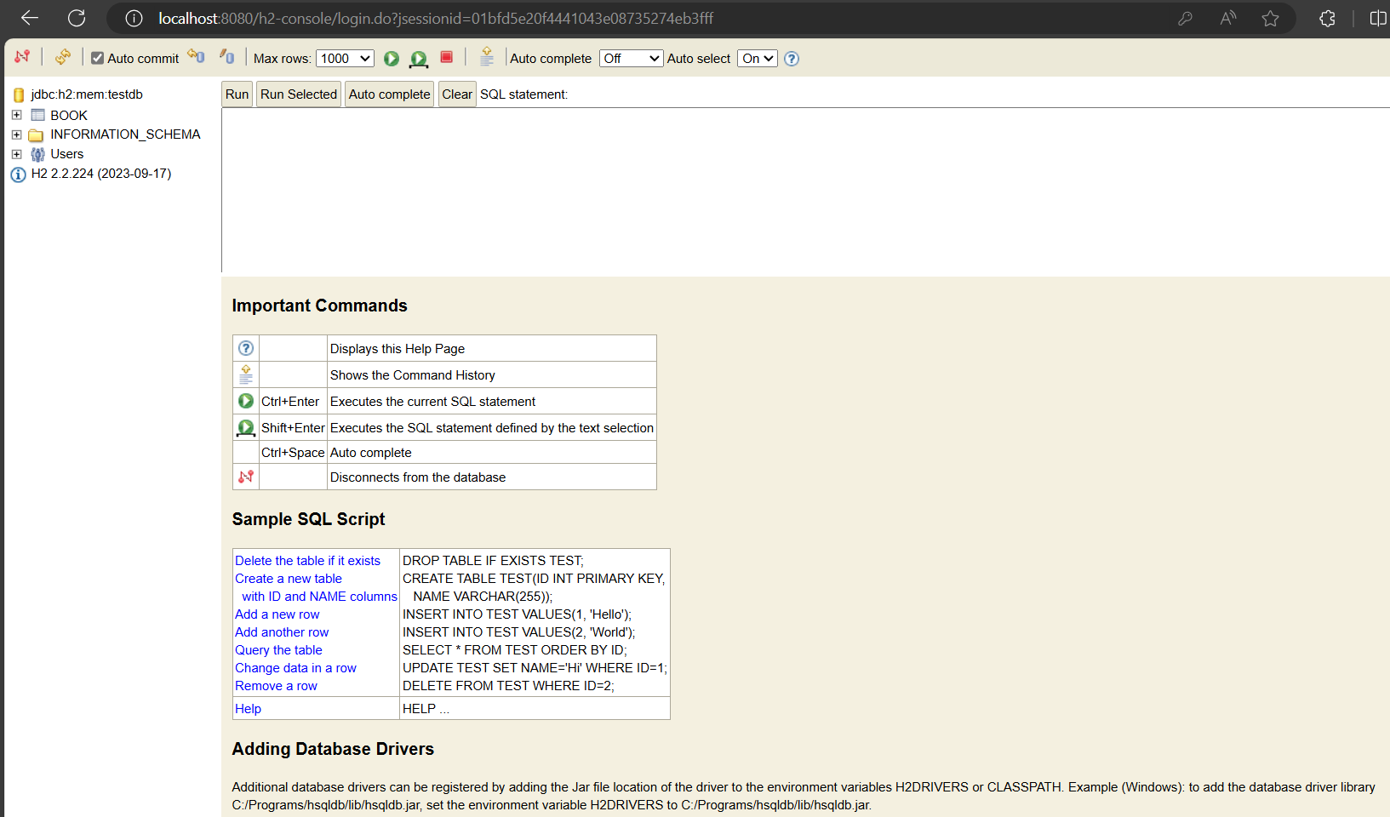

Using the POST operation to add the book

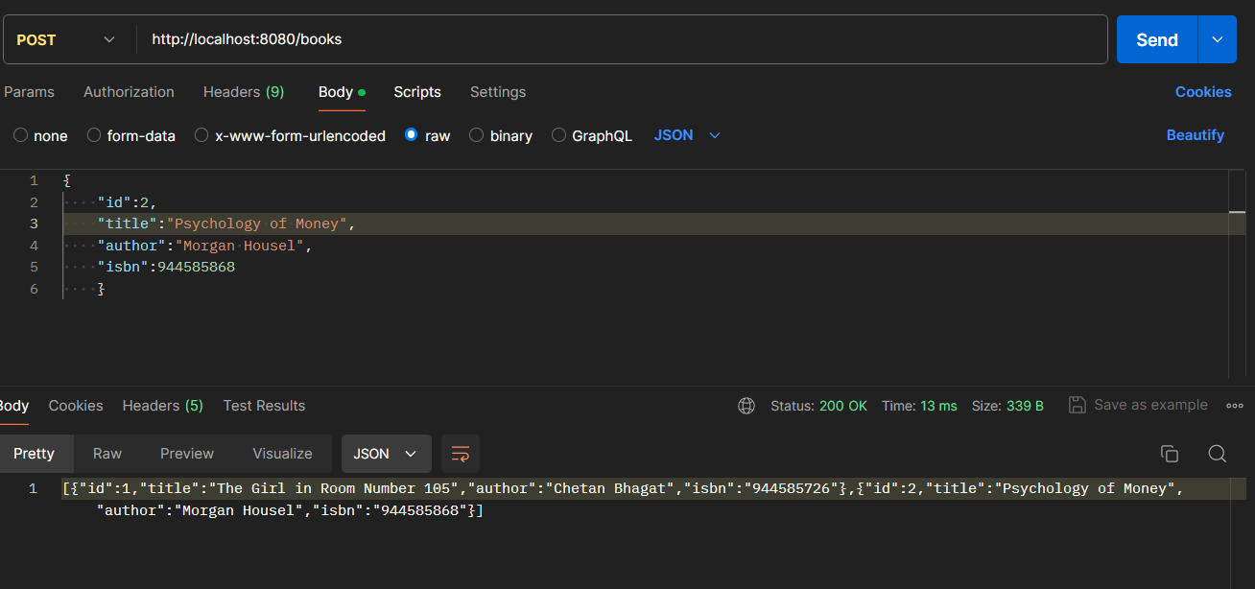

Using the PUT operation to update the file

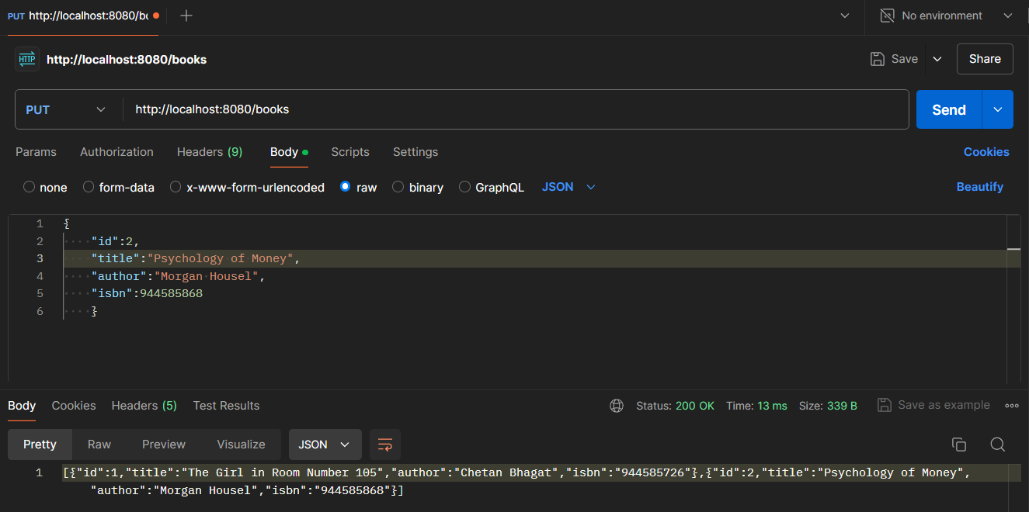

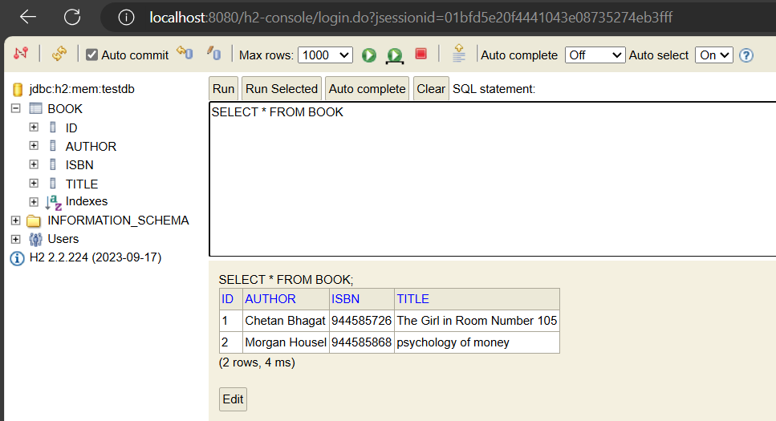Using the GET operation to see the file

